**Converting a wired Canon printer into wireless using a Raspberry Pi**

[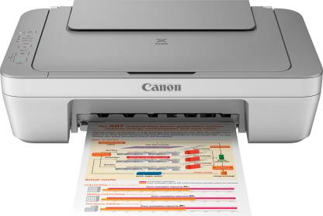](https://github.com/dhankhar313/Coursera-Courses/blob/master/An-Introduction-to-Programming-the-Internet-of-Things-(IOT)-Specialization/6.%20Programming%20for%20the%20Internet%20of%20Things%20Project/Resources/printer.jpeg)

**1. Component Testing:**

**The printer:**

Test the printer with a normal computer that has Windows on it

Test the printer with a normal computer that has Linux on it

Test the printer on Raspberry Pi using CUPS software

Test the printer on Raspberry Pi using a shell command

**The server code:**

Test the server code by receiving a simple message

Test the server code by receiving a file

**The client code:**

Test the client code by sending a simple message

Test the client code by sending a file

**The LEDs:**

Test each LED individually

Test LEDs together

**2. Integration Testing:**

**The printer & The server code:**

Test the server code by receiving a file and printing it

**The server code & The client code:**

Send a simple message from the client to the server

Send a file from the client to the server

**The LEDs & The server code:**

Test LEDs on the server code

**The whole system:**

Send a file from the client to the server, print the file, and turn LEDs into high and low